DevelopmentTest Plan – CBOEdirect
Reduce Quantity Limit for Quotes
(SEDL#4867)

Mike Hasbrouck

Contents

Pre-Setup 3
Option Inter-Day Add State Error 3
Test Case 1: Add new product for class in PRE_OPEN state 3
Verification 3
Test Case 2: Move the entire class into OPENING_ROTATION and add another new product 3
Verification 3

Pre-Setup

- Pick an class from hybrid session W_MAIN which is in OPEN state

Reduce Quantity Limit for Quotes

Test Case 1: Add quotes with a quantity > 99999

Verification

Trader Gui should display message:

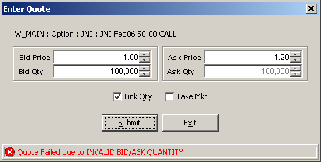

Also, trader server log should display:

low information 2006/8/28 11:58:13.99 HybridTradeServer1 test8HybridTradeServer1devenv2 "MarketMakerQuoteServ
iceHome:MarketMakerQuoteService>>> Quote for [MJB,230444668] has invalid quantity (too big), bid: 100000 ask:100000"

Test Case 2: Add quotes with a quantity < 99999

Verification

Quotes should be accepted with no Exceptions/messages in logs

